Chapter 20: Kingdom Protista

K. Protista contains a diverse group of mostly ________________________________. They were probably the first forms of eukaryotic organisms on the planet and appeared about ________ billion years ago.

Protists are classified based upon the structures they use to ___________and how they obtain ____________(food).

20-2
Animal-like protists move using_________, ____________, or__________. Some are incapable of movement.
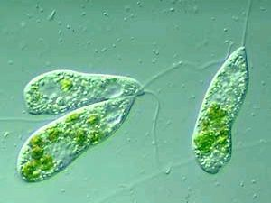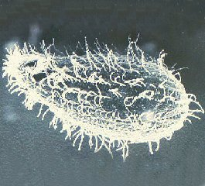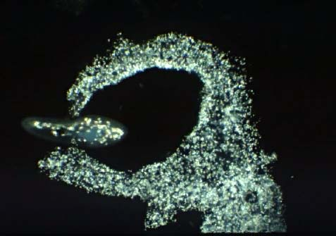
Flagella Cilia Pseudopods

Reproduction occurs through binary fission, conjugation, and some can form gametes. Draw each in the space below:

Binary Fission Conjugation

Animal-like protists obtain their food from their surroundings by eating other protists or by decomposition (______________). Many protists are parasitic and cause diseases like_______________, ___________________________, and_________________.

20-3 and 20-4: Plant-like Protists
Plant-like protists contain pigments (like_____________________) that allow them to photosynthesize (___________________). Some are able of movement to obtain the nutrients they require.

Many plant-like protists form ____________________consisting of many cells (Spirogyra, Volvox) but _______________________________________and therefore do not have __________________.
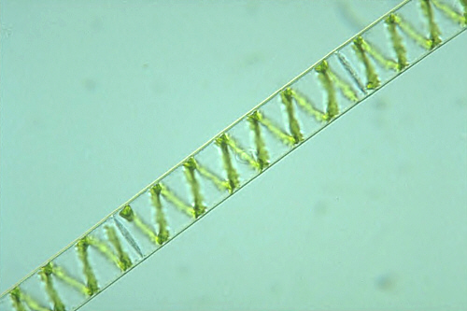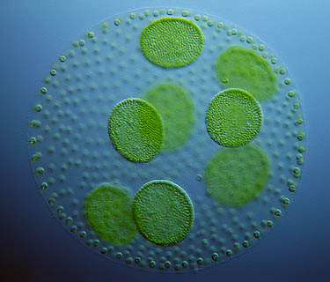

During their lifetime many algae contain both a haploid stage and a diploid stage (Alternation of____________________). The haploid stage produces a ______________and is therefore called the ______________stage (gamete plant).

When the gametes ____________they form the diploid stage which eventually produces spores that grow into the entire organism. Because it developed from a spore it is called the ___________________(spore plant).

Chapter 21: Kingdom Fungi
Fungi are __________________________________ with cell walls made of ________(unique to this Kingdom). Except for yeast all fungi are______________________.

The body of a fungus is made of thin filaments called ________________(Hy-fee) tangled together to form a_____________________.
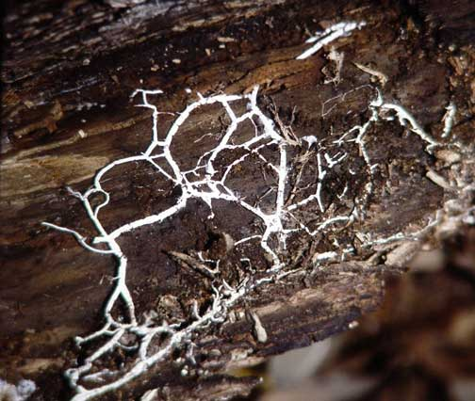
Fungi reproduce both sexually and asexually (budding/spores).

All fungi are _______________and most are _____________________(decay). A few cause parasitic diseases like _____________________and athlete's foot.

Fungi sometimes live in a __________________relationship with algae forming lichens or with plants forming mycorrhizae.

Examples of other common fungi include;______________, molds, ________________, and Penicillium.

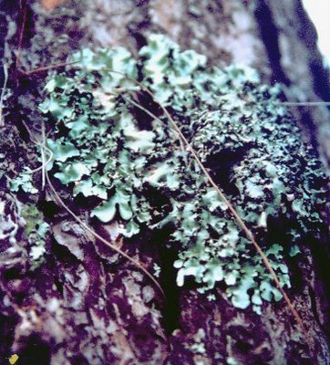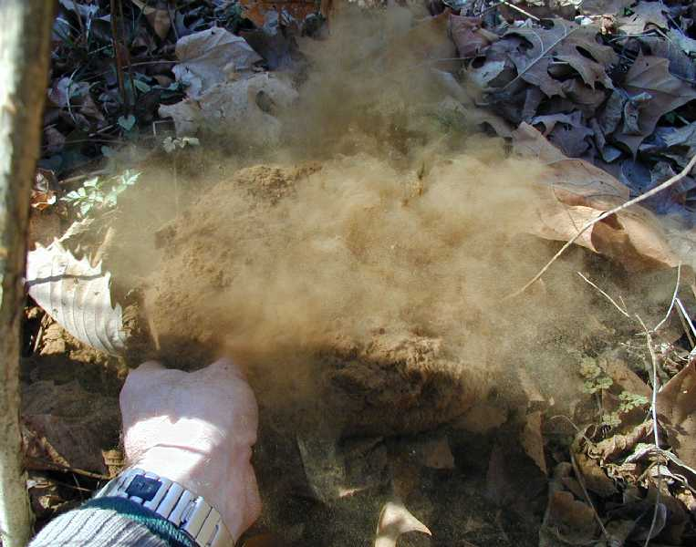
LICHEN Puffball Spores

