APES: Chapter 16
Solid and Hazardous Waste

*16-1 What are Solid Wastes/Hazardous Wastes
Any unwanted or discarded material that is not a liquid or a gas is called solid waste.
The United States produces about 1/3 of the world’s total.
Municipal Solid Waste (garbage) in the United States has doubled since 1970 (506 billion pounds or 1700 pounds per person).
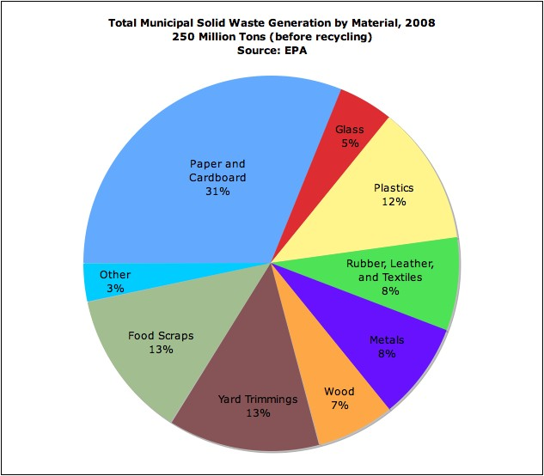

Hazardous waste is defined as any solid or liquid material that contains toxic, carcinogenic, or teratogenic compounds; easily catches fire; is reactive or unstable so that it explodes or releases toxic fumes; or is corrosive.

It does not include radioactive materials, discarded household toxins, mining wastes, or wastes from many small businesses.

16-2 Solutions: Producing Less Waste

Solid and hazardous wastes are often buried, burned, or shipped to other locations (waste-management: a high-waste approach).

Waste prevention (low-waste approach) takes the approach that “there is no away” and wastes should therefore be recycled, reused, or not created in the first place (60-80% could be eliminated).

1st:Waste/Pollution Prevention
2nd: Reuse, Repair, Recycle
3rd: Management (Landfills, incinerate, etc).

Key components of this strategy would include:
- consume less
- redesign manufacturing processes
- develop products that are easy to repair, reuse, or recycle
- design products that last longer
- eliminate or reduce unnecessary packaging (example)
- use trash taxes
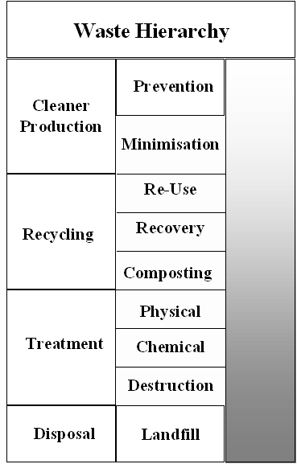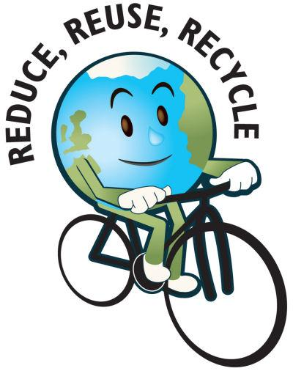

** Solutions: Cleaner Production/ Selling Service
Some analysts suggest the need for an ecoindustrial revolution built around the concept of cleaner production or industrial ecology. In effect manufacturers would mimic natural chemical cycles or establish resource exchange webs between themselves and the community they serve.
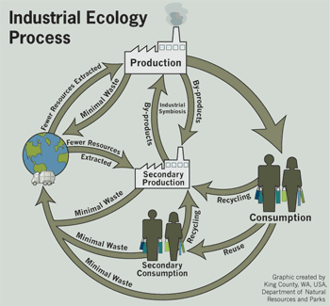
http://www.youtube.com/watch?v=bk5vwFbGEP4 industrial ecology

Changing from a material flow economy (buying goods) to a service flow economy (lease or rent services the goods provide) may also help reduce solid wastes.

Xerox, for example, leases copy machines then takes the machines back at the end of the contract. The machines are then remanufactured or their parts are recycled.

Additional money has been saved by redesigning copying machines to work with fewer parts, less paper, to be more energy efficient, and to use less paper and chemicals.

Detoxifying Wastes

Many believe that in the future microorganisms and enzymes will be the best way to treat hazardous waste (bioremediation). This appears to be effective for many organic wastes but does not appear to work well for toxic metals or some chemicals.
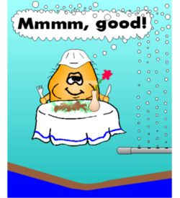
Phytoremediation involves the use of natural or genetically engineered plants to filter, remove, or soak up (pollution sponges) chemical wastes.

This process is cheap and clean but is slow, only works to a limited depth, and may create toxic plants that need to be eliminated.
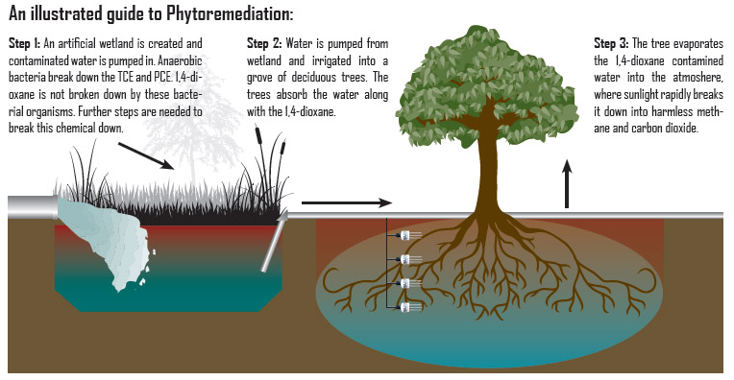

Sanitary landfills are used to spread or compact solid wastes in layers which are then covered with clay or plastic to prevent leachate (water contaminated as it flows through the landfill) from spreading.
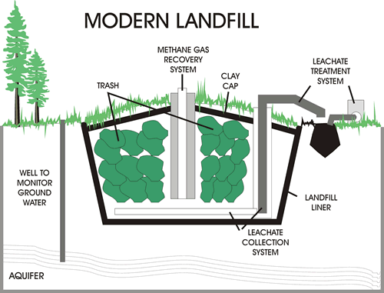
In the most modern landfills gases generated by decomposition are monitored and removed through a series of holes and pipes drilled or placed in the landfill (see page 421).

Older landfills are serious sources of ground and surface water pollution and many states are simply running out of places to place landfills.
http://www.hippocampus.org/AP%20Environmental%20Science

Deep-well disposal has been suggested as an alternative for the storage of some hazardous wastes. It is relatively cheap, simple, and easy to do. It does however encourage waste production, and can result in leaks if the well casings crack (old age, earthquakes).

Other options include; surface impoundments (ponds, pits), securing hazardous waste landfills, storage in above ground buildings.

Shipments or movements of hazardous wastes in the United States (500,000/year) result in approximately 100 deaths, 10,000 injuries, and the evacuation of 500,000.

***Hazardous Waste Regulation
The Resource Conservation and Recovery Act (RCRA, 1976) requires the EPA to identify and set standards for the management of hazardous wastes and requires companies that produce large amounts to obtain permits stating how much waste they are managing (cradle-to-grave).

In 1980 the SUPERFUND (Comprehensive Environmental Response, Compensation, and Liability Act) was passed. Using taxes on chemical raw materials it created a trust fund that provides money to identify toxic sites, to clean them, and to require responsible parties to foot the bill (polluters-pay principle).

Brownfields are abandoned industrial sites that are contaminated (junkyards, old gas stations, factories). There are about 500,000 in the U.S. and many could be converted to parks, nature reserves, and athletic fields if they were cleaned.

A Low-Waste Society
Many sources of hazardous and radioactive wastes are located in communities inhabited by the poor (environmental injustice). Most people believe in the not-in-my-backyard (NIMBY) but many are not politically powerful enough to prevent the disposal of wastes in their neighborhoods.
http://www.youtube.com/watch?v=QOAam1poJFg Environmental Injustice

A not-in-anybody’s–backyard (NIABY) or a not-on-planet-earth (NOPE) approach emphasizes pollution prevention instead of pollution clean-up.

In 2001 the UN Commission on Human Rights declared that being able to live free of pollution is a basic human right. A global treaty to control persistent organic pollutants (POPs) should be ratified soon and has targeted the 12 worst chemical pollutants (dirty dozen) for eventually elimination (DDT can still be used by some countries to control malaria).

http://www.youtube.com/watch?v=pHDsigxcoWo

