HONORS BIOLOGY
Chapters 22-25: PLANTS

Plants are multi-cellular ____________________that have cell walls made of______________________.

Plants go through an Alternation of Generation in which the ____________stage (sporophyte) produces the ________________stage (gametophyte) which produces the haploid stage. (Drawing page 552: on handout).

Name three things that plants need to survive:
1.
2.
3.
They must also exchange _____________to survive.

How different plants meet these needs is the key to understanding plant evolution.

Draw the cladogram on page 554 ( on handout).

The first plants evolved from multi-cellular green algae living in freshwater (not the oceans).

How do we know this?

These eventually produced enough _________to change the planet's atmosphere.
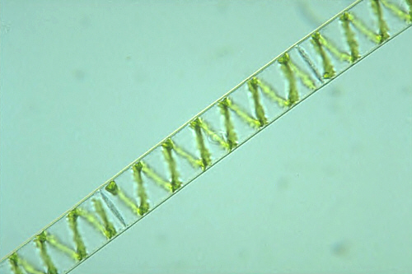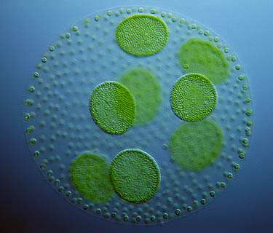
They were still dependent upon water to spread their gametes (much like amphibians). The most advanced plants today ( _______of plants) are ___________________plants.

The simplest plants are the _____________(Bryophytes) that lack vascular tissue.
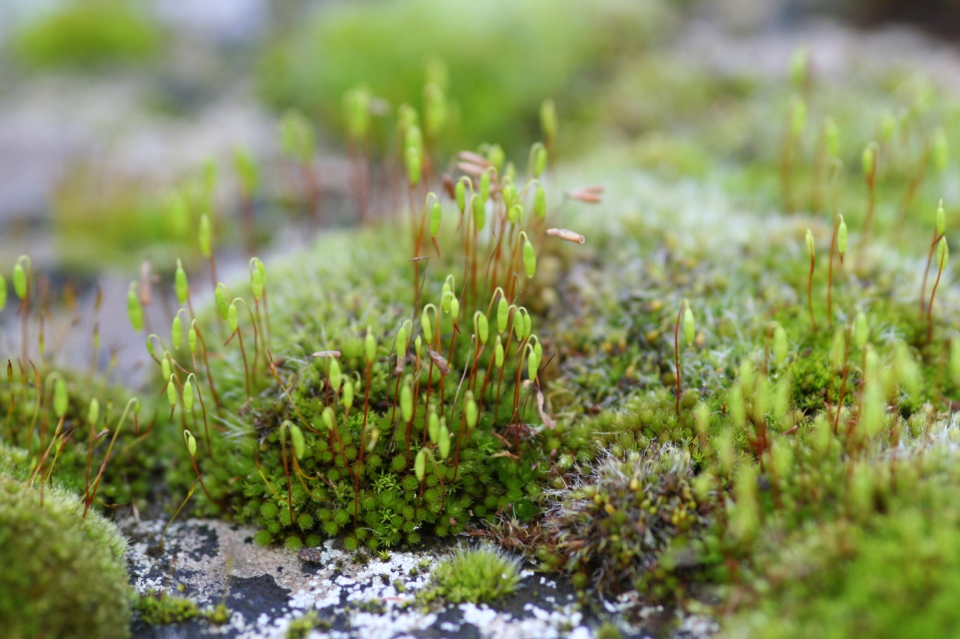

As a result they cannot get very ________________because they have no way to move ______________and ________________through the plant. Because they lack ____________they remain dependent upon ______________to reproduce.

Section 22-3: Seedless Vascular Plants
The evolution of vascular tissues has been critical in the development of plants. Name the two types of vascular tissue and what each transports through the plant:
1.

2.

(much like veins and arteries move material through most animals).
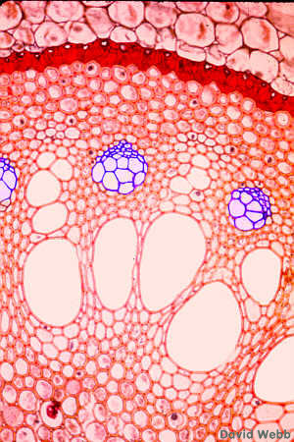

The first vascular plants were_______________. Like other plants ferns they have__________________, leaves (called_________________________), and _________________plus lignin (a substance that makes cell walls rigid). These structures allow most plants to get much ____________than mosses. Ferns still need water for their gametes to reach each other (fertilization).

22-4: Seed Plants
Eventually plants evolved_______________________________.

Why is the evolution of seeds important?

Gymnosperms (pine trees) hold their seeds on _______while angiosperms (flowering plants) cover their seeds with a ____________________tissue (fruit).

The male gamete in seed plants is the tiny ___________________grain that must reach the female gamete (wind, pollinators).

A seed is a plant _____________________surrounded by a supply of_______.

What is the function of the seed coat?

Draw a picture of a seed (page 565: on handout)

Flowers are _______________________organs which attract pollinators and increase the Darwinian Fitness of the angiosperms. After fertilization the fruit helps ____________________________of angiosperms.

Chapter 23
23-4: Leaves
Leaves are where a plant conducts ____________________(sugar production). Leaves are covered with a _______________to prevent them from losing water. ________________are located on the underside that open and close to allow gasses to move in and out of the leaf.

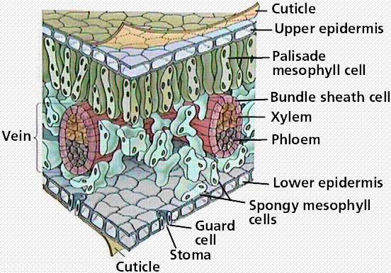

Water moving through the vascular tissue in a plant evaporates from the leaves (__________________________).
24-2 Seeds and Fruit
Some of the leaves in the angiosperms have been modified into reproductive structures (flowers).
_________________are the outermost ring of leaves around a flower and are usually green. The colored leaves are called _______________are typically used to attract pollinators.

The most modified leaves are the _______________(male parts: anther and filament) and pistils or __________________(female: ovary, style, and stigma).
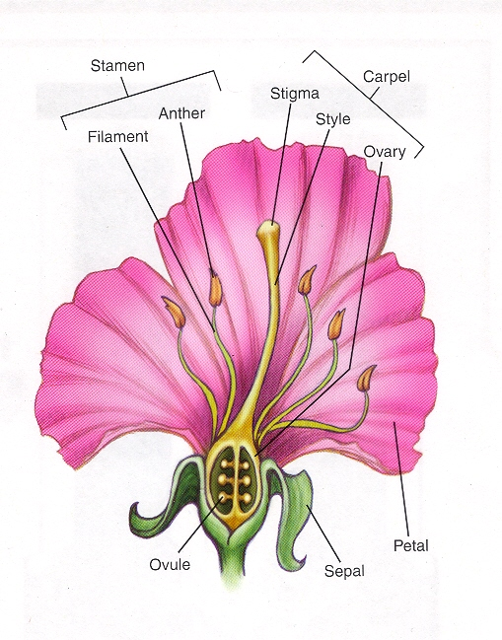
In biological terms a fruit is a ________________________________________ ___________________________________________. Fruit is used to help disperse the seeds.

Germination refers to the early_____________________. Many plants require very specific conditions for their seeds to germinate properly.

Chapter 25 Plant Hormones and Growth

What are Hormones: ___________________________________________________ __________________________________________________________________________________ Plant growth, development, and responses are controlled by hormones.

How plants respond to light (____________________________: direction or amount) and gravity (__________________________) are controlled by hormones called______________.
