Chapter 1 Describing Motion

Assessing existence while failing to embrace the insights of modern physics would be like wrestling in the dark with an unknown opponent. –Brian Greene

EQ: Use diagrams to describe the motion of an object on a Cartesian Coordinate System (position/time graphs).
EQ: Demonstrate the ability to determine an object’s Path Length.

Chapter 1: Description of Motion
To measure (_____________________) motion requires the ability to measure the position of a moving object at different ________________________.

https://www.bing.com/videos/search?q=Eadweard+Muybridge&&view=detail&mid=84D246557800399CCF1C84D246557800399CCF1C&&FORM=VRDGAR

The motion of an object can be followed using a Cartesian Coordinate system (__________________/_________________ graph).

Path length (s) can be defined as the _______________________ traveled over a period of time (t). Path length is a scaler unit (total distance) and always positive.

EQ: Be able to explain the concepts of speed, average speed, and displacement.
EQ: Solve problems involving speed, average speed, and displacement.

1-2 SPEED
_____________________________ motion occurs when an object moves equal distances during equal amounts of time. _______________________ (v) is defined as the change in path length over the change in time.

Non-uniform motion is typically more common. _____________________ speed ($\overline{v}$) represents the change in position (Δs) over a particular time period (Δt).

1-3 DISPLACEMENT
The change in ____________________________ of an object from one place to another is called ________________________. It is typically represented by an arrow connecting two points. Displacement does not show the path the object takes during this motion.

EQ: How are scalar and vector quantities different?
EQ: How are resultant vectors drawn?

1-4 VECTOR ALGEBRA
Vectors and Scalers: ___________________________ have both magnitude and direction. Quantities that have only magnitude are called _____________________. Vectors are usually represented with _______________ FACE letters. The direction is indicated with an arrow, the magnitude with the length of the arrow.

https://www.bing.com/videos/search?q=vector+and+scaler+quantities&&view=detail&mid=7BF14A442E4A624CEB4D7BF14A442E4A624CEB4D&&FORM=VRDGAR

Vector addition occurs when 2 or more vectors (A, B, C, etc.) are combined (tail to head) into a “____________________ vector” (R).

B

A + =
R

POLYGON RULE
______________________ vectors are added the same way two vectors are added (head to tail). The resultant vector is found by connecting _________ of the first vector to the ______________ of the last arrow.

A ________________________ vector is a vector when the same magnitude pointing in the opposite direction.

A Negative vector of A

Subtraction of Vectors occurs when the negative of a vector is added to another vector.

When multiplying a vector quantity by a scalar one simply “______________________” the length of the vector quantity by the scalar factor.

1-5 Components of Vectors

EQ: Be able to use trig functions to solve problems involving moving objects.

Although Vectors are typically represented by an arrow showing its magnitude and direction they can be designated by their components along the X and Y axis.

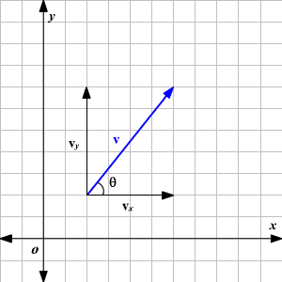

Trigonometric functions can be used to relate the two methods (See Appendix A on page 905).
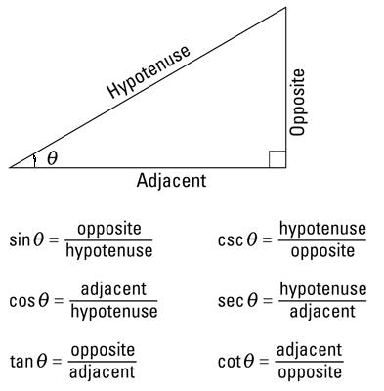
Practice with trig functions

1-6 Velocity
Speed is a scalar quantity measuring the rate of motion (magnitude only) while velocity is a vector because in addition to the rate a direction is indicated.

Average velocity is calculated using: $\overline{v}$ = D
Δ t

