Honors Biology
Kingdoms and Phyla Characteristics
Chapter 19: The Bacteria
Characteristics
The bacteria are all ____________________and are classified into two groups; the ____________________and archaebacteria. Eubacteria have the carbohydrate __________________ in their cell walls while the archaebacteria do not. Most archaebacteria live in harsh environments like extreme __________________or low________________________.

Bacteri are found in three common shapes: bacilli (rod), cocci (spheres), and spirilla.
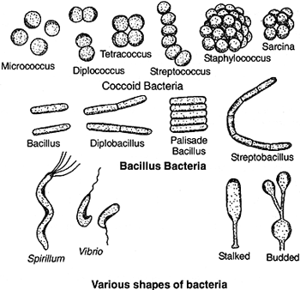
Metabolism
Bacteria are either _______________________(cannot make their own food) or ____________________(make their own food through photosynthesis.

If they use chemicals to meet their energy needs the prefix "_________________" is added (chemoheterotrophs or chemoautotrophs). If they also need light the prefix "_____________________ " is used. Aerobic bacteria need oxygen while anaerobic ones do not.

Growth and Reproduction
Most bacteria reproduce asexually using _________________fission (splitting in two). Some can also reproduce sexually in a process known as______________________________.
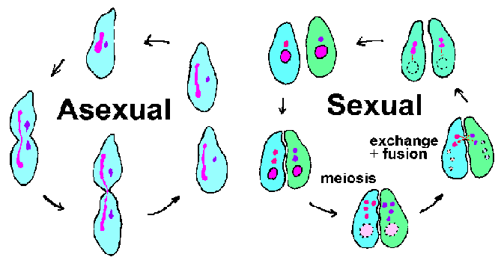
Under stressful conditions bacteria may form an __________________________which has a thick cell wall and some cytoplasm. These structures can remain dormant for years.
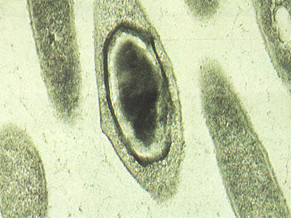

Importance
Bacteria are essential _________________________in ecosystems and are one of the few organisms that can take nitrogen out of the air so that other organisms can use it (nitrogen__________________________). Bacteria are also used in many commercial products (cheese, wine).

Viruses
Viruses are technically not ____________because they can only carry out life functions in the presence of other_____________. Viruses that infect bacteria are called_________________________.
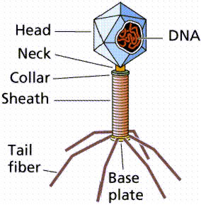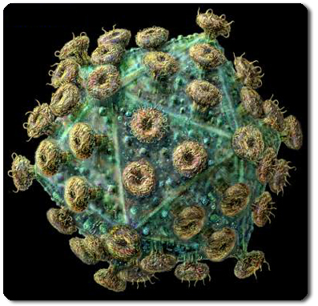

A virus consists only of a piece of ___________or RNA surrounded by a _______________coat (capsid).

A virus ________________in one of two ways: a _________________infection or a lysogenic infection. In both the virus injects its _________________acid into the host cell (the ___________________coat stays on the outside).
The nucleic acid then instructs the host cell to make more of the _____________coat.

In a lytic infection the cell then bursts (___________________) releasing new viruses to begin the cycle again. In a lysogenic infection the nucleic acid may remain inactive for years.
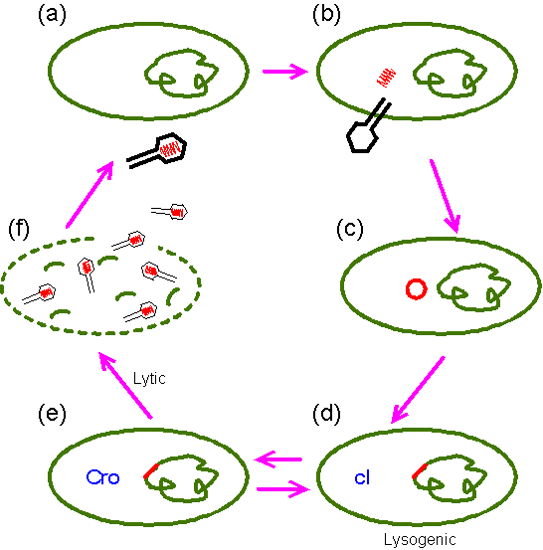

Diseases
What are Pathogens? ________________________________________________________

Many diseases are caused by bacteria including;_________________, scarlet fever, diphtheria, and many infections.
Bacterial diseases are treated with ________________________(weakened forms of the pathogen) or _____________________________(prevent the reproduction of the pathogen).

Heat and disinfectants kill many bacteria while dry conditions and cold slow their growth.

Viral diseases include;___________________, cancer, ______________________, measles, smallpox, Ebola, and the common cold.
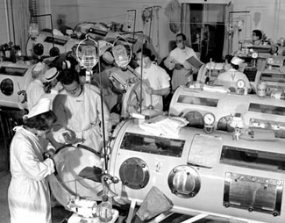
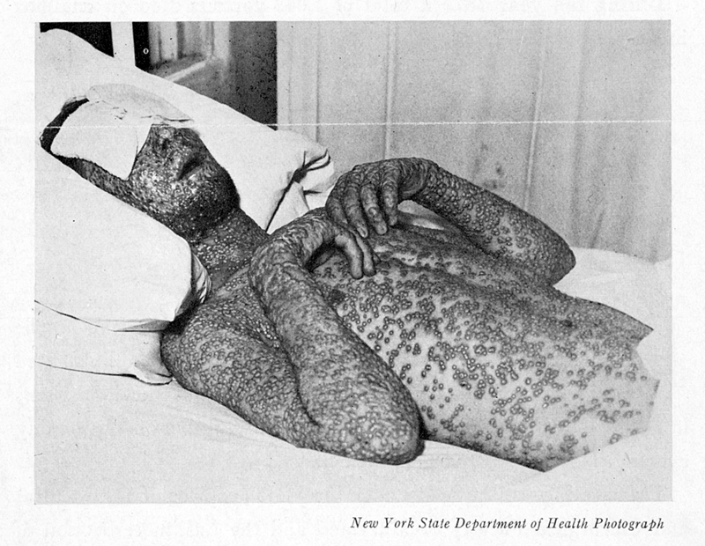

Many bacterial diseases are viral diseases are spread by diseases carrying agents called_______________. Insects (mosquitoes), ______________, and ___________are common vectors.

