Chapter 13: Genetic Engineering
EQ: How have humans attempted to ______________the genetics of various organisms? What are their goals?

13-1 Changing the Living World
Humans have made use of the genetic variation that occurs in all living things through the process of ____________________breeding.

How is it accomplished?: By allowing ______________those organisms with the ____________________traits to _____________, humans have been able to produce many different breeds of some species including:
1. 2. 3. 4.

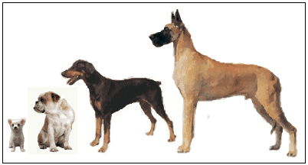

What is hybridization? ______________________________________________
_____________________________________________________________________________(disease resistance and high crop yields).

What is the goal of inbreeding? __________________________________________
________________________________________________________________________________
Many dogs breeds are inbreed often causing genetic problems (joint deformities, blindness) to develop.

Increasing Variation
Some breeders will _________________________mutations to increase the amount of genetic variation they have to work with.

What are the two most common ways this is done?
1. 2.

Most of these mutations are __________________ to the organisms. Occasionally useful mutations (like ____________________able to digest oil) are produced.

Many plants (citrus fruit, flower varieties) have been exposed to levels of chemicals that prevent their _____________________from separating thus creating _____________________________(many chromosomes).

Continue with summary on back
Summary:Write answers to each of the following questions using complete sentences.

1. How are the processes of selective breeding and inbreeding different? How are the goals of each different?

2. Explain why scientists attempt to induce mutations in some organisms.

3. How is genetic engineering fundamentally different than selective breeding?

EQ: What are the basic techniques used to manipulate DNA?

13-2 Manipulating DNA
Advances in ____________________now allow scientists to overcome some of the ________________________associated with selective breeding and inbreeding. The goal of genetic engineering is to make the desired genetic changes____________________________________: the DNA.

What is the first step in genetic engineering?

What is the function of Restriction enzymes?

Finally the DNA fragments are separated in a process called gel electrophoresis.

In this process _________________is used to pull _________________fragments through a gel. The _______________________and lighter fragments are pulled the _____________________and farthest.

Using the DNA Sequence
Once isolated a DNA fragment can be read, studied, and changed.

What is Recombinant DNA?
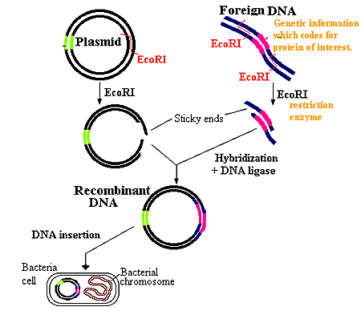

Continue on back
What process is used to make copies of the recombinant DNA?

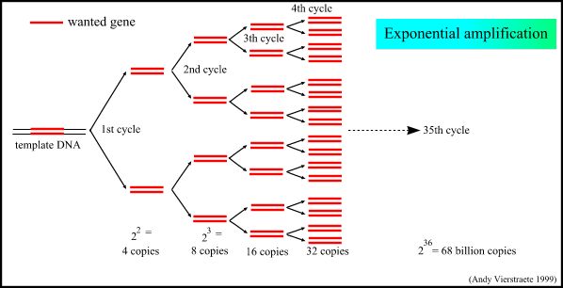

PCR does artificially what a cell would do normally during replication.

13-3 Cell Transformation
What is Transformation?

Bacteria can be transformed by placing them in close proximity to foreign DNA.

What is the function of a genetic marker?

Plant cells can be transformed by using bacteria (already transformed) that carry specific genes.

How are animal cells transformed?

It is important to remember that only a small number of cells are transformed using these techniques. Genetic markers indicate successful transformations.

Summary: Name and briefly describe three techniques used to manipulate DNA?

EQ: How have humans applied the techniques of genetic engineering?

13-4 Applications of Genetic Engineering

__________________________organisms contain genes from other______________. These are also called ______________________(genetically modified organisms). Transgenic bacteria, because they reproduce quickly, are used to produce____________, growth hormone, and one of the __________________factors needed by hemophiliacs.

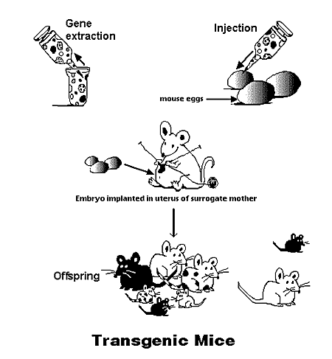

Transgenic animals have been produced that grow faster and produce a better quality meat. Some transgenic plants produce a large percentage of the food supply used to feed livestock.

Cloning

_______________________are genetically __________________organisms produced from a _____________________egg. Simple organisms like _______________are easy to clone. Cloning of _______________is much more difficult and remains very______________________________.

