HONORS BIOLOGY:
Chapter 12: DNA and RNA

The Structure of DNA
The structure of DNA was discovered in ______________by two scientists named James ________________and Francis_______________ . Drawing on the work of Rosalind _________________ (x-ray diffraction) they were able to announce that DNA must be a___________ ____________.
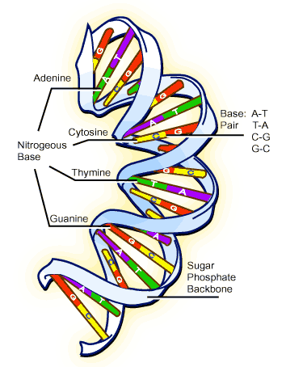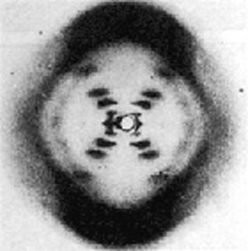

A double helix looks like a twisted _________________or spiral _______________held together by hydrogen bonds. Remember DNA (___________________) is a long chain of nucleotides (______________________=sugar, phosphate, base).

In DNA there are four different bases: ___________________(A), _________________(T), cytosine (C), and guanine (G). Adenine always bonds ____________________and Cytosine always bonds with__________________.
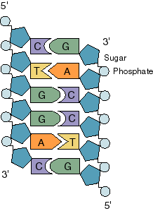

There must always be the same amount of thymine as adenine in a DNA molecule.

The amount of DNA in _______________________is greater than the amount found in prokaryotes. The DNA in a simple bacteria (E.coli) contains 4,639,221 base pairs. To fit this into the bacteria cell requires the DNA to be _______________many times.

Eukaryotic cells contain about ________ times this amount of DNA (about 1.0 meter in each cell). The DNA is tightly coiled around proteins called _____________forming a substance called chromatin.

Like all models, the DNA model proposed by Watson and Crick must explain what is observed in the real world. In this case:

1.
2.
3.

HW #1: Section Assessment page 294: #’s 1-4

DNA Replication

________________________________= the process by which DNA makes DNA. Replication occurs in the nucleus (eukaryotes) and makes use of free_____________________________.

The process begins when a series of _____________________begins to separate the double helix at the hydrogen bond.
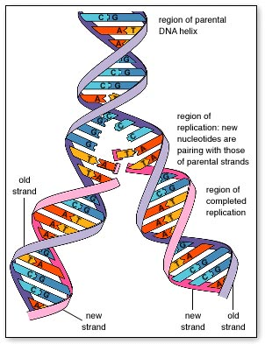

Each strand (___________________strand) then acts as a template on which two new complimentary strands (_________________________) are built.

Free nucleotides are joined to the parent strand by an enzyme known as DNA ________________________. It also “proofreads” the new molecule and corrects errors in replication.

http://www.youtube.com/watch?v=z685FFqmrpo
http://www.youtube.com/watch?v=4jtmOZaIvS0

HW #2: Section Assessment page 299: #’s 1-5

12-3 Protein Synthesis
A __________________________is a series of _________________(group of three nucleotides) that controls the building of a____________________________.
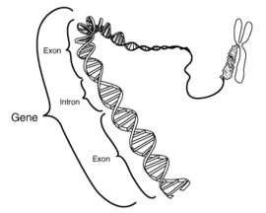
A protein is a polymer made of ______________________acids.

How does the information on the DNA (which is in the nucleus) control the placement of amino acids into the correct order to make a protein (at the ribosome in the cytoplasm)?

The first step involves making a near copy of one side of a DNA molecule. This single strand copied off the DNA is called__________________.

The process of making RNA using a DNA template is called_______________________________.

Differences between DNA and RNA include:
1. it is a _______________________strand (not a double helix)
2. the _____________________(ribose) is different than the one found in DNA (deoxyribose).
3. the base _________________________replaces thymine
4. RNA can leave the _____________________
5. it comes in three different types (messenger RNA, transfer RNA, and ribosomal RNA)

Fill in the missing bases in the following DNA molecule that is undergoing transcription.
DNA Strand

L l l l l l l l l l l l l l l l l l l l l l l l
C T G C C T A T C A A T T C C G G C

A U C U U A
l l l l l l l l l l l l l l l l l l l l l l l l

RNA Strand

During transcription RNA polymerase separates the DNA molecule and uses one side as a _________________________________to make a single strand of RNA.
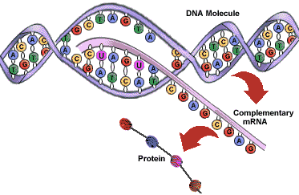
RNA polymerase begins the process of transcription at special sequences of DNA known as promoters.

http://www.youtube.com/watch?v=ztPkv7wc3yU cover screen at end
http://www.youtube.com/watch?v=5MfSYnItYvg

HW #3: Section Assessment page 306: #’s 1-4

The Genetic Code

Proteins are made by joining amino acids into long chains called _________________________ (polymers). The properties of each protein are determined by the _____________________of amino acids it has in it structure. Changing the sequence of amino acids changes the protein and its behavior. The trick is to get amino acids into the ___________________________sequence.

Each mRNA (carries the genetic message from the nucleus to the ribosome) molecule consists of codons three nucleotides long.
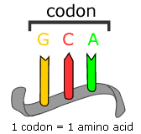

Each codon “codes” for a particular amino acid (see Figure 12-17 on page 303).

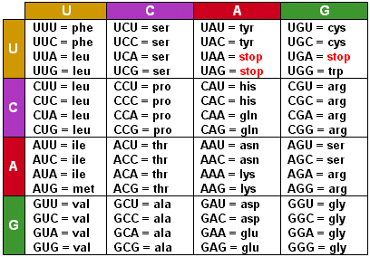

____________________________is the process by which various types of RNA are used to make a protein.

mRNA _______________________the genetic message to the ribosome.
tRNA carries _______________acids to the ribosome (see picture below)
rRNA ____________________(translates) the codons
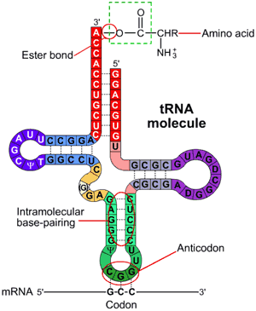

Once in the cytoplasm, ribosomes (rRNA) attach to the mRNA and begin to read the code one codon at a time.

The _________brings the correct amino acid to the site of protein synthesis (ribosome). Each tRNA has a special anti-codon that matches only one mRNA codon.
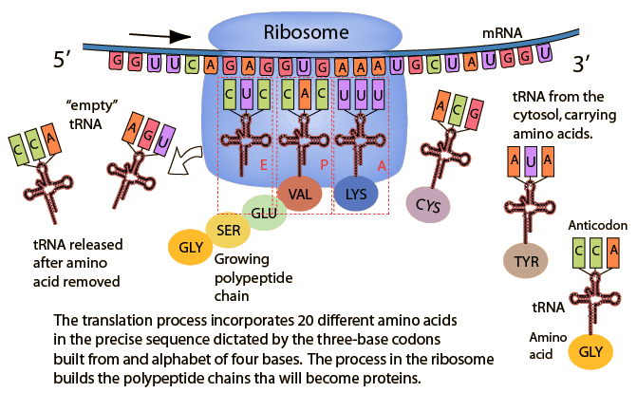

The rRNA only allows the appropriate tRNA to place its amino acid onto the mRNA.
_________ ________ ________ ________ ________ ________ _________ _________ amino acids

A U G C U C U U G A A G U U A A U C A G C U G A
L l l l l l l l l l l l l l l l l l l l l l l l

The DNA determines the mRNA sequence which then determines the sequence of amino acids (a protein). The DNA segment that controls for the building of a protein is called a____________________.

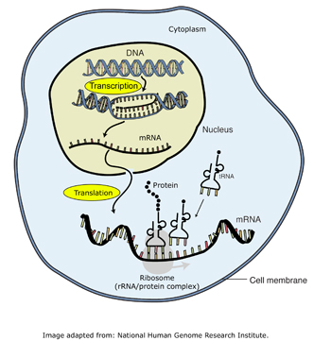

https://www.youtube.com/watch?v=-zb6r1MMTkc&list=PLB0DA39AA75BC5D68&index=14

http://www.youtube.com/watch?v=nl8pSlonmA0&list=PLB0DA39AA75BC5D68&index=47

HW #4: Section Assessment page 308: #’s 1-4

Name____________________________ Score: ___________

Directions: label the following diagram with the words in the word bank. One term is used twice. You will continue to take this quiz until you get them all correct (twice).

WORD BANK: Ribosome, Translation, Protein, tRNA, mRNA, Transcription, DNA, Nucleus

HONORS BIOLOGY
EQ: How do the major types of mutations occur?

Section 12-4 Mutations

A mutation is defined as a ___________________change in the genetic information. There are three common causes:
a. ___________________________
b. chemical exposure
c. ____________________________

There are two common types:

1. gene mutations (__________________mutations) occur at only a small number of nucleotides. They can either be _______________________or___________________________.

Methionine Leucine Leucine Lysine Leucine Isoleucine Serine Stop

A U G C U C U U G A A G U U A A U C A G C U G A

l l l l l l l l l l l l l l l l l l l l l l l l
Some substitutions do not affect the amino acid sequence and therefore do not impact on the organism (________________________mutation).

For example, substitute a guanine (G) for the second cytosine (C) in the second codon above (change CUC to CUG). What amino acid is coded for by the new codon? _________
____________________________are much more dramatic because they tend to cause frameshift mutations.
For example, delete the second uracil (U) from the third codon. What does the third codon now instruct the rRNA to do? _________

This may result in changes in the amino acid sequence after the point of the mutation and therefore change the protein that will be made.
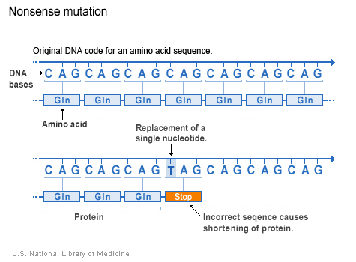
2. ___________________________mutations change the number or structure of the chromosomes inherited.

For example: Down's Syndrome is a result of inheriting an extra 21st chromosome. The extra chromosome is a result of non-disjunction during the cell cycle.
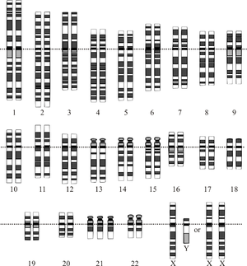

Sex-linked traits are chromosome mutations much more common in males than females.
(Color blindness power point).
Practice:

Mutations are essential to life because they generate genetic diversity that would not otherwise be possible. They can be:
1. __________________________________
2. __________________________________
3. inversions or
4. translocations

TRANSLOCATION DUPLICATION
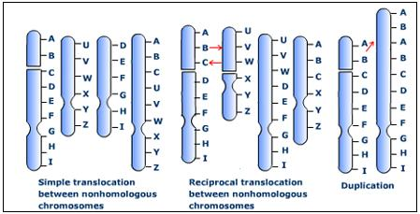

TRANSLOCATION
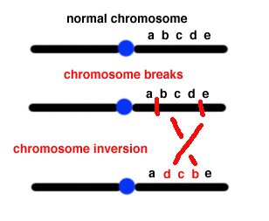

12-5 Gene regulation
Only a small fraction of the genes in a cell are expressed at any given time. How is it determined which genes will be expressed?

The key to this question is the molecular structure of the DNA molecule.

a.__________________________: binding sites for RNA polymerase.

b. start and stop codons

c.____________________________: groups of genes that work together.

d.____________________________________: genes that can be turned off

http://www.youtube.com/watch?v=iPQZXMKZEfw

Answer the following questions as you watch the Youtube Clip.

1. What is the function of the enzymes produced by the lac operon?

2. What is the function of the repressor genes located in front of the lac operon?

3. How does the presence of lactose change the repressor protein?

Eukaryotes
Gene regulation in eukaryotes is similar but more complex than it is in prokaryotes.

The regulation of gene expression is important to the process of ___________________________(the process by which cells become specialized in structure and function).

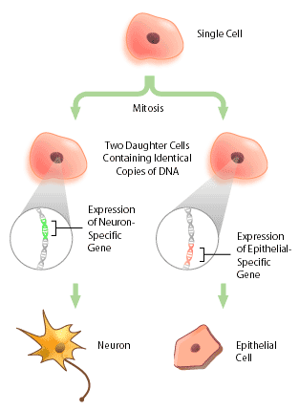
Differentiation is controlled by hox genes. Mutations of these genes can have dramatic effects on where organs grow (mouth parts replaced by legs in flies).

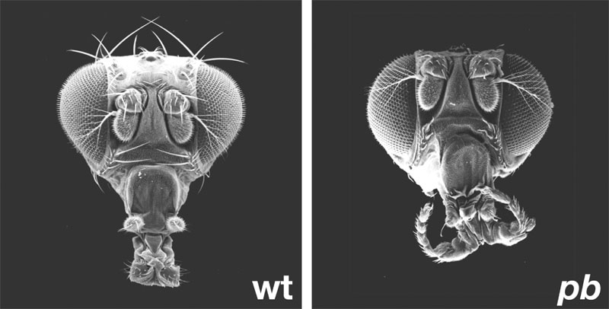

Development lab

END Of Chapter Vocabulary Assignment (Parent signature required)

