Honors Biology: Chapter 10
Cell Growth and Cell Division

EQ: ______________________________________________________________________________
___________________________________________________________________________________

10-1 Cell Growth
What are the three major reasons cells go through cell division:
1:
2:
3:

The cells of large organisms are typically_______ _________ than the cells of a small organism. You are ________________ today than when you were born because you have _________ cells, not because your cells have grown larger.

As cells become larger there are __________ demands placed on the cell’s _________. In addition, the larger cells become the more ___________________ it is to move enough ________________ and ________________ across the cell membrane (surface area to volume).

EQ: ______________________________________________________________________________

10-2 Cell Division
Before cells become too large they divide to form two “_____________________” cells. Cell division occurs during what is known as the cell cycle (see Figure 10-4).

What does the word replicate mean in cell division?

Why must cells replicate their genetic information?

Define the word Chromosomes (be sure to briefly describe their structure):

Chromosomes are not visible throughout most of the cell cycle. Once replication occurs the strands of ___ shorten and become visible as two “sister” chromatids.

What is a centromere?

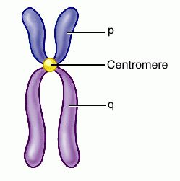

All species have a characteristic number of chromosomes, which are organized into homologous (near _________________) pairs.

Humans: ______chromosomes in 23 pairs
Potato: 48 chromosomes in 24 pairs
Housefly: 12 chromosomes in ____pairs.
Chicken: 78 chromosomes in ____pairs?

Does it appear that chromosome number is related to the complexity of the organism?

In humans one pair of chromosomes is referred to as the sex chromosomes.

Females: ___ ___

Males: ___ ___

Many genetic disorders are related to the fact that males are missing a piece of their genetic information.
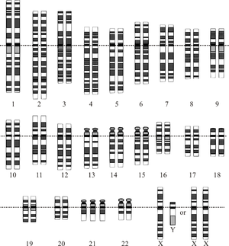

HW #1: page 243 Sect 10.1 #’s 1, 2, 3.

Chapter 10 &11 Cell Division

EQ: ______________________________________________________________________________
___________________________________________________________________________________

The life of a cell is divided into _______ phases.

There are two _________ phases (G1 and G2) separated by the S phase during which _____________________ occurs.

At the end G2 the cell organizes its genetic information so that each daughter cell will get a copy and then splits in two (M phase).

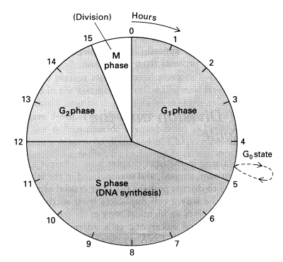

What three parts of the cell cycle are commonly called Interphase?

The M phase is broken into several shorter phases: P____________________, M____________, A_________________, and T_________________.

What happens at the end of Telophase?

Interphase is essentially the period of time when the cell gets ready for division. ________________________of the genetic material occurs during the end of this stage.
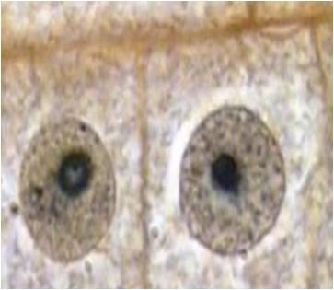

The first and ______________phase of mitosis is Prophase. What two important events occur during this phase?
1.
2.
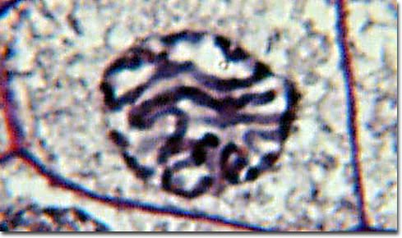
Microtubules of proteins called ____________________begin to radiate out from the centrioles and attach themselves to each ____________________at the______________. By the end of Prophase the nuclear membrane has disappeared.

During Metaphase the centromeres ___________________________of the dividing cell (equator).
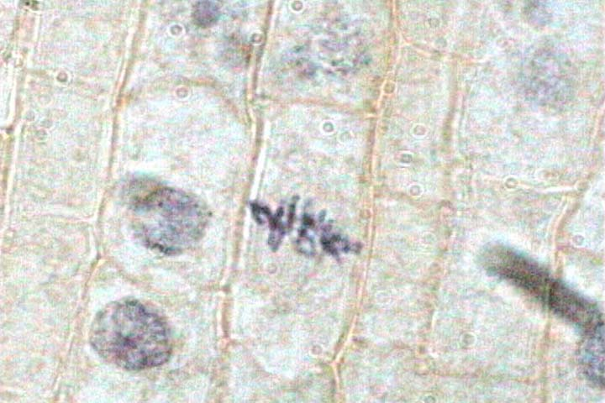
Anaphase begins as the _________________________are split and each chromatid is pulled by the spindle fiber to opposite sides of the cell.
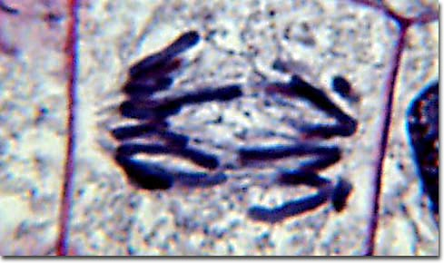

During telophase the chromatids begin to________________, the spindle and centrioles disappear, and the nuclear ________________reforms.
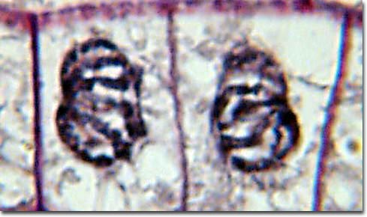

Mitosis end when the genetic information from the daughter cells is separated (cytokinesis) into two new ________________cells either by the membrane (animals) or the cell plate (plants).
https://www.youtube.com/watch?v=C6hn3sA0ip0

HW #2: page 249 Sect 10.2 #’s 1, 2, 3, 4.
Section 11-4 Meiosis (page 275).

EQ: ______________________________________________________________________________
___________________________________________________________________________________

What are Diploid cells?

Examples include _________________________, ___________________, white blood cells and many others. Cells that are diploid are sometimes referred to as being 2N.

What are Haploid cells?

The only examples in humans are the reproductive ________________(eggs and sperm). Haploid cells are referred to as being 1N.

Hapolid cells are created in a process called_________________.

What is crossing over?

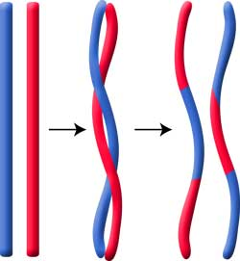

What is the great advantage of crossing-over?

Meiosis is essentially going through mitosis twice except ________________is skipped the second time (no replication). The end process is to create ________________(4 in males; one in females).

HW #3 page 278 Sect. 11-4 #’s 1, 2, 3, 4.

